Pleasant View Hotel

**SHWEGONTAIN YANGON**

No. 155,West Shwe Gon Taing Street, Bahan Township,Yangon, Myanmar   
 Tel: 95(1) 552657, 552658, 552782, 552892, 554181

Reservation \+959 444434860,444434859 .



**To**

**Asia Expeditions Co., Ltd (Myanmar)**

**House #04, RM (E), 5th Floor Corner of Anawyahtar Road and Lower Pazundaung,Yangon,  
Tel: +95-1-200 401,+95 -9-5062644 +95 -9-401533484 +95-9-254219046  
Email:**[**phyo@asia-expeditions.com**](mailto:phyo@asia-expeditions.com)**,**[**myanmar@asia-expeditions.com**](mailto:myanmar@asia-expeditions.com)

**Contract Rate Agreement   
 (2018 – 2019 Season)**

**Attention To : Ms. Phyo Ma Ma( Operation Supervisor ),**

Date: 26 – Feb - 2018

Thank you for your supporting our Pleasant View Hotel ( Shwe Gon Taing) Yangon &

We are pleased to offer the below contract rate ;

**Rate in USD per room per night (1st April 2018 to 31st  March 2019)**

|  |  |  |  |  |  |  |
| --- | --- | --- | --- | --- | --- | --- |
| **Room Type** | **No of Rooms** | **Low Season (May, June, July, Aug, Sep)** | | **Peak Season ( April 2019, Oct,Nov,Dec,Jan,Feb,Mar, )** | | |
|  |  | **Double** | **Triple** | | **Double** | **Triple** |
| **Superior** | **29** | **30** | **-** | | **40** | **-** |
| **Deluxe** | **11** | **50** | **+15** | | **60** | **+15** |

**Terms & Conditions**

1. Above room rates are non-commissionable. Rates are inclusive of service charge and tax and daily breakfast.

2. Airport transfer services available on request by additional charges.

3. All confirmed rooms by reservation shall be Check in 14:00 PM and check out 12:00 Noon.

**Child Policy**

1. We will provide daily breakfast FOC for ONE child under 4 years old sharing a parent’s bed.   
   ( Above One child : USD 5 per day per child)
2. USD 8 net per child between 8 to 12 years old sharing a parent’s bed.

**Reservation**

1.Travel and Tour agents to reserve directly Sales and Reservation office, Yangon.

2. Hotel must receive final rooming list for group tour at least 7 days before arrival and must include arrival and

departure flight time detail.

(Hotel reserves the right to release all rooms if this requirement is not met within the time stated.)

**Room Payment**

1. The management holds the right to require 25 % deposit of the total room charges for Group

Booking not later than 15 days prior to the arrival date**.**

2. Full room payment should be paid 5 days prior to guest’s arrival date. Otherwise, rooms will not

be reserved.

3. Full payment of total room charges must be paid on room reservation/confirmation date in Peak

seasons; which are Christmas, New Year and Water Festival Holidays.  
4. The full room charge shall be settled in cash in United States Dollars.

5. All payment will be paid at Pleasant View Hotel.

**Cancellation & no show Policy**

1. In the event of cancellation by clients for confirmed bookings(prior to check in date )-
   * within 30 days 25 % of total room charges
   * within 21 days 50 % of total room charges
   * within 14 days 75 % of total room charges are will be charged.
2. For cancellation less than 14 days and no show 100% of the total room reservations value will be charged.
3. For earlier check out than confirmation date, hotel will retain all room payment for the balance of the stay. Case by case consideration will be done for emergency check out.

Accepted By: Confirmed By:

………………… 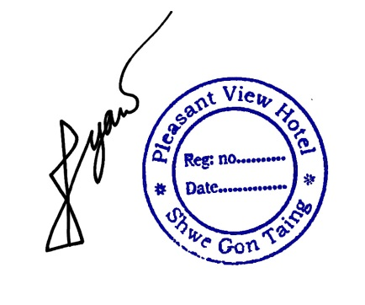

..…………………………

**Kyaw Zin Hain ( Mr )**

**Asst: General Manager**

**Pleasant View Hotel**